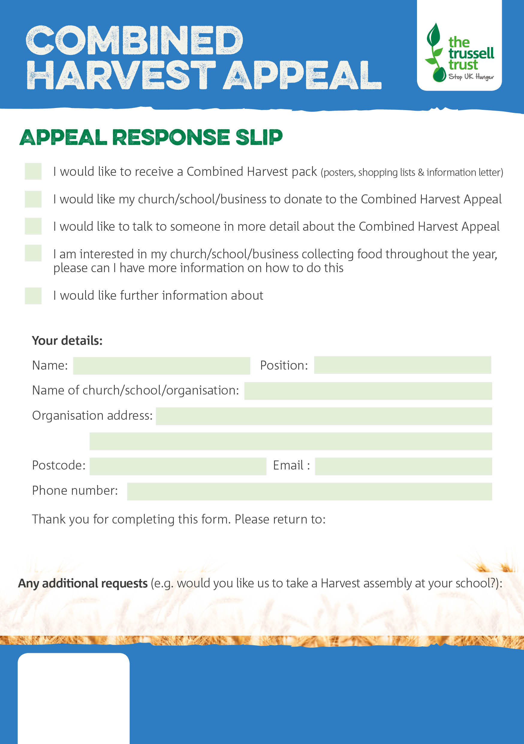

During any foodbank session or email to [norwoodfoodbank@btinternet.com](mailto:norwoodfoodbank@btinternet.com)

Norwood & Brixton Foodbank

XXXXX XXXXXX

XXXXXX.foodbank.org.uk

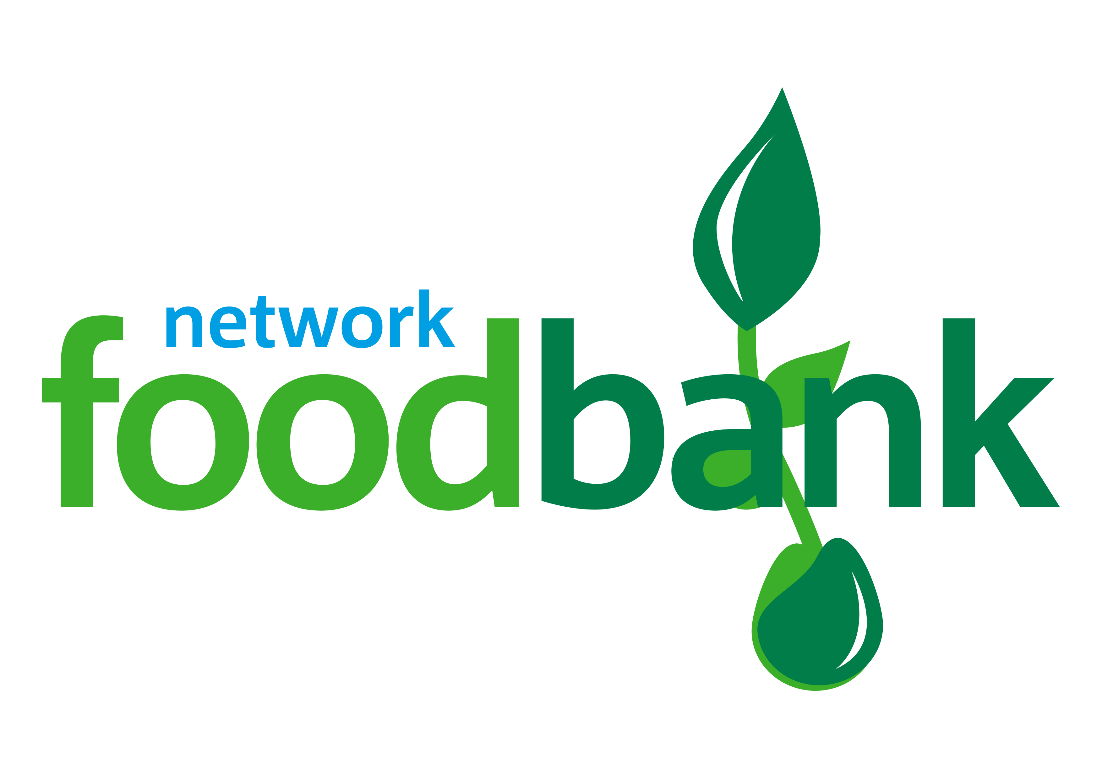

norwoodbrixton.foodbank.org.uk

Registered Charity in England & Wales 1151274