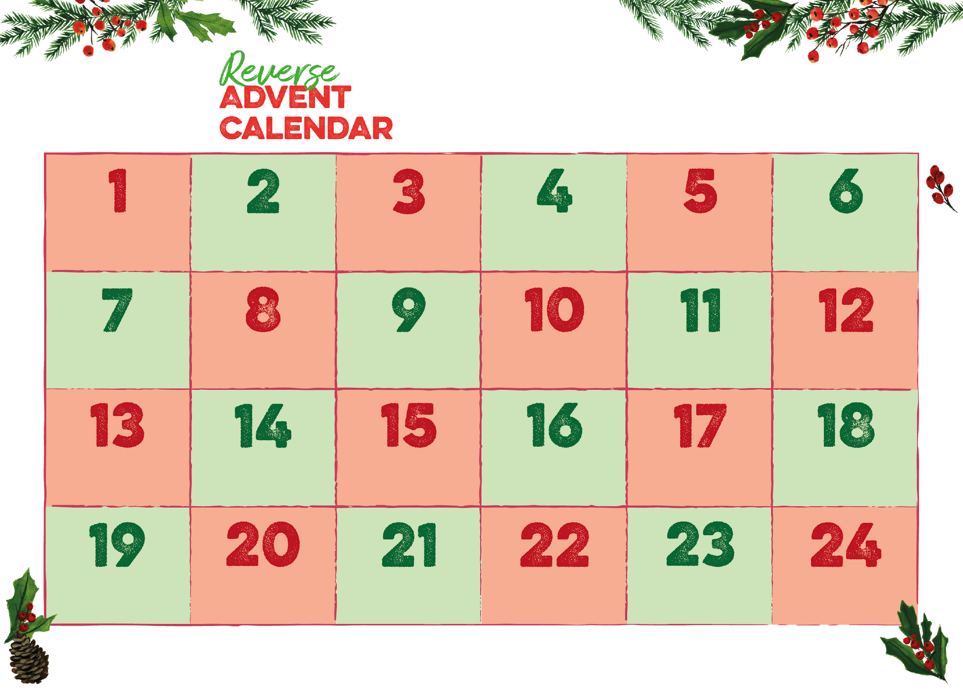

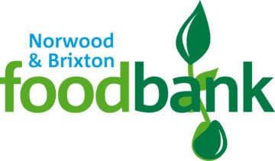



**Please check with us to find out our opening times around Christmas**

**and to check if there is anything in particular we’re running short of.**

**Email address: norwoodfoodbank@btinternet.com**

**Telephone Number:07722121108**

Registered Charity in England & Wales (1151274)

**UHT custard**

**Jam & peanut butter**

**norwoodandbrixton.foodbank.org.uk**

**Tinned fruit**

**Tinned Meat**

**Cooking oil**

**Washing up liquid**

**Shower gel**

**Cereal**

**Rice pudding**

**Shampoo**

**Chocolates**

**Sponge pudding**

**Hand wash**

**Washing powder**

**Toothpaste**

**Themed cakes**

**Biscuits**

**Tinned fish**

**Pasta sauce**

**UHT milk**

**Coffee**

**Hot chocolate**

**Fruit juice**

**Rice pudding**