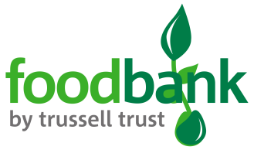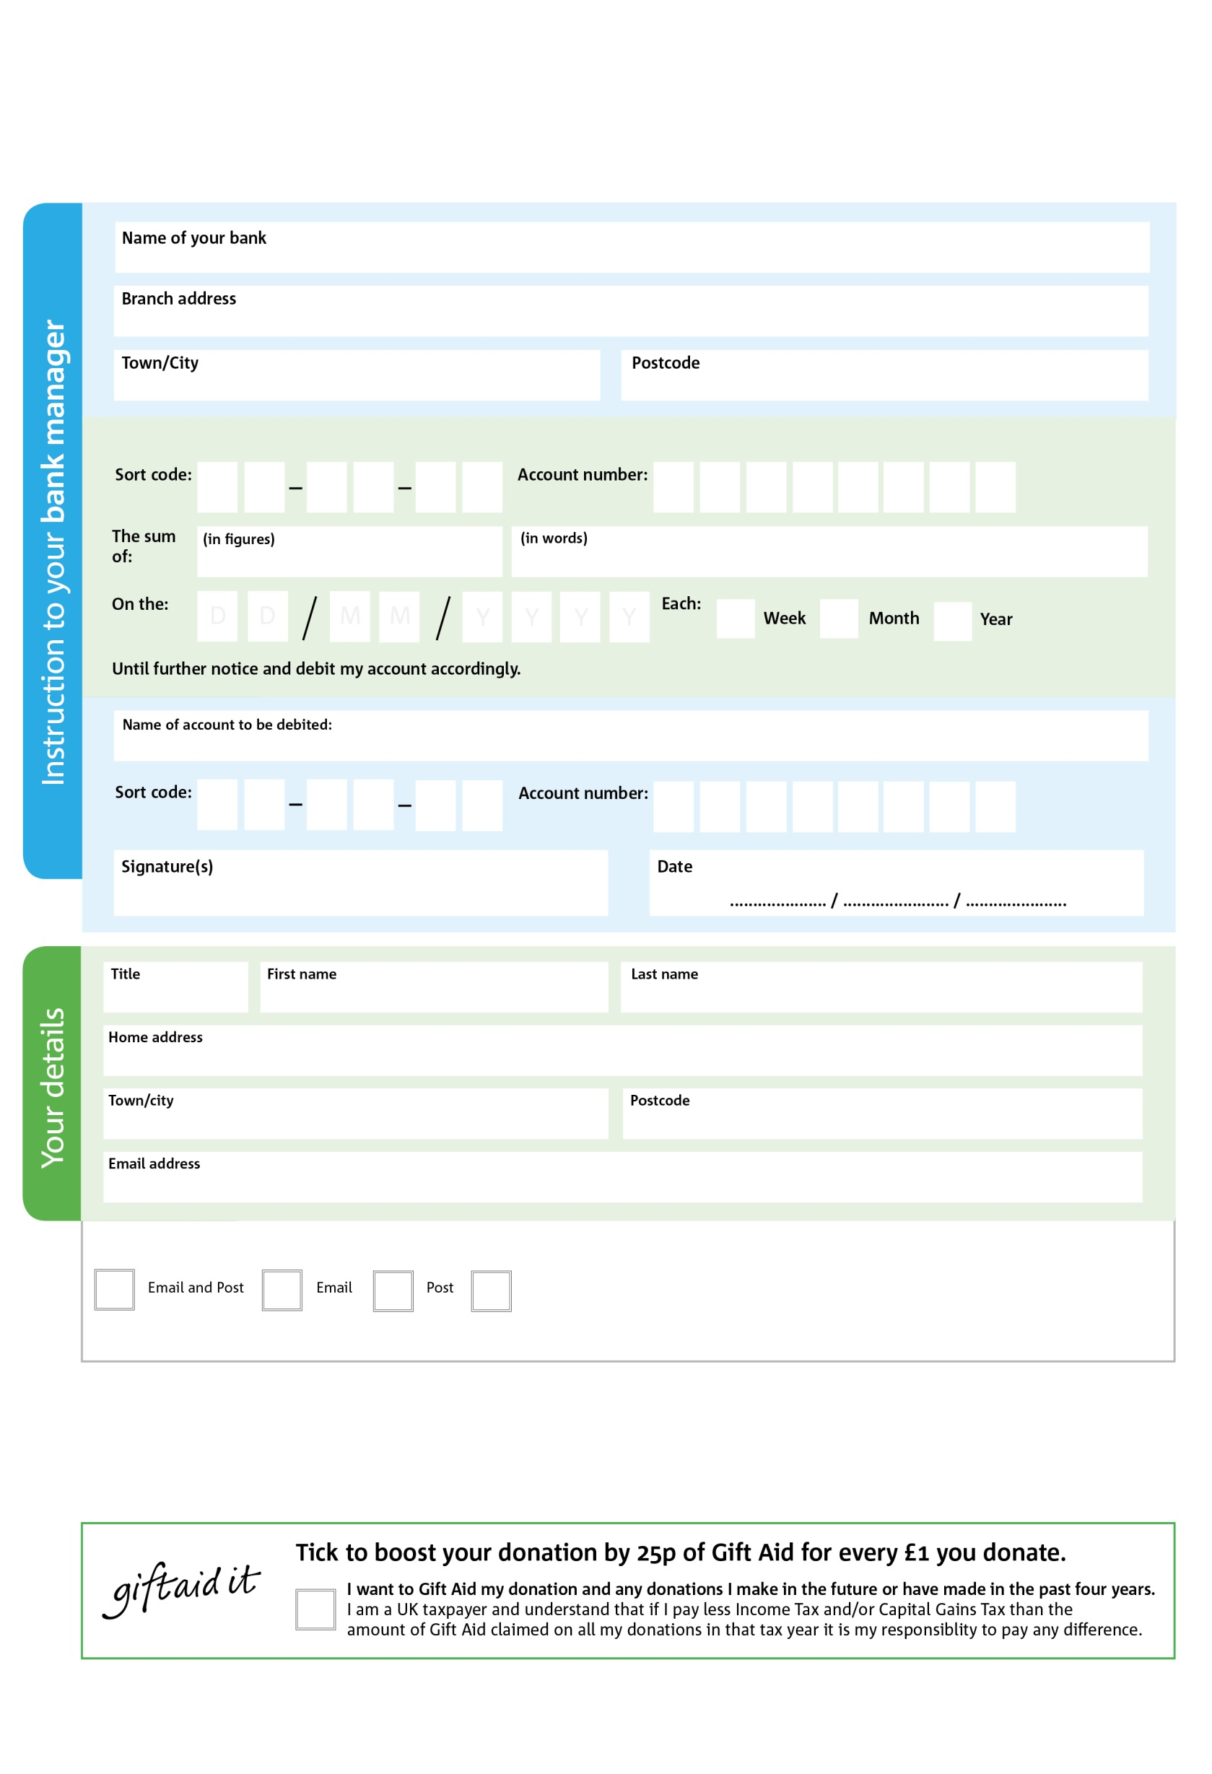

Reg. Charity No: 1151274 | Reg. in England & Wales

I do not wish to receive future communications from Norwood and Brixton Foodbank

I do not wish to receive future communications from XXXXXX Foodbank

We would love to keep you up to date with information about Norwood & Brixton Foodbank. Please tick your preferences

0X

0

9X

0

V

6

V

0

V

9

1

V

3

V

4

V

9

V

2

V

8

2X

3X

You can change your preferences any time by contacting us at office@norwoodbrixton.foodbank.org.uk

POSTAL ADDRESS: Norwood and Brixton Foodbank, c/o St Luke’s Church, Knight’s Hill, West Norwood, London SE27 0HS, Charity No 1151274

Please pay Norwood & Brixton Foodbank,

**Please pass this form onto the foodbank, using the foodbank’s address at the bottom, who will save a copy for their records. They will then send it onto your named bank or building society.**

**Data protection**

Norwood & Brixton Foodbank is committed to protecting your privacy and will process your personal data in accordance with the Data Protection Act 1998. Norwood & Brixton Foodbank collects information to keep in touch with you and supply you with information relating to our work. Norwood & Brixton Foodbank will never sell or pass your details to anyone who isn’t directly working on our behalf.

**Standing Order Mandate**

**Norwood&Brixton.foodbank.org.uk**