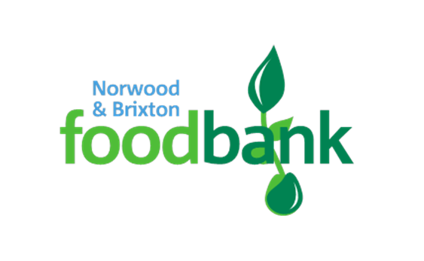

NORWOOD & BRIXTON FOODBANK
Volunteer Application Form
Thank you for your interest in volunteering with Norwood and Brixton Foodbank. To process your application please complete the form fully in black ink and sign it, before mailing or scanning and sending by email.
QUESTIONS | ANSWERS
Date
Title
First Name
Surname
Address
Postcode
Email
Mobile Number
Emergency Contact Details – please give
Name, Relationship, Mobile Number, Other Telephone Numbers

Medical Conditions: Do you have any health issues that could affect your roles for example asthma, heart condition, mobility issues, back pain. This helps us allocate you to a suitable role.
Date of birth
DBS – please give details if you hold a current DBS certificate
Driving – can you drive and do you own a car with a clean driving licence.
First Aid – do you have any first aid qualifications – please give details and date of expiry of your certificate(s)

Volunteer Opportunities
Please do also consider your commitment before signing up, a minimum of once a month for regular help or otherwise best to sign up for ad hoc support. In line with many organisations, all new volunteers will need to attend an interview/initial meeting before starting a new role.
For an up to date list of volunteer positions available please refer to the website https://norwoodbrixton.foodbank.org.uk

Please list the roles you are interested in and ensure you have considered carefully the hours you can give before completing this information.

Please tick the location(s) where you would like to volunteer
Norwood – St Luke's Church, Knights Hill,
WEST NORWOOD London SE27 0HS.
Tuesday 10am – 1pm or Friday 10am – 2pm

Brixton - St Paul's Church, 184-188 Ferndale Road,
Brixton SW9 8AH
Tuesday or Saturday 10am – 1pm
Streatham - St Margaret's Church, Barcombe Ave, SW2 3BH
Wednesday 7pm – 8.30pm
Saturday 9am – 11am
Driving – available midweek daytime for ad hoc pick ups. Need clean licence
Please tell us about any skills you have which might be useful in foodbank setting – for example counselling skills, accounting skills, warehouse management, first aid, admin, grant applications, fundraising driving etc.

Please give us an outline of any previous volunteering roles/work experience. Please include any skills we have not listed but might be useful to foodbank.

References
Please give two referees. In order to volunteer at the Foodbank, we must first secure two written references. Please ensure at least one reference is work based and one character based. Neither should be a relative. If you are applying and are part of a faith community, we would ask that one reference be from a faith leader.

Please tell those you are giving as referees and encourage them to respond promptly

Name of Referee No 1
How does referee know you?
Contact E mail
Telephone
Name of Referee No 2
How does referee know you?
Contact E mail
Telephone

DATA PROTECTION
Norwood and Brixton foodbank will hold your details on file but will not release them to a third party.
Norwood and Brixton Foodbank is committed to protecting your privacy and will process your personal data in accordance with the Data Protection Act 1998. Your data will not only be used in relation to your volunteering activity. It will only be seen by foodbank personnel responsible for your volunteering. It will not be sold or passed to any other organisation.
A full data privacy statement for volunteers is available from the foodbank on request.

Please sign and date this form I confirm that the above information is complete and correct. I consent to the processing of this data in the consideration of my application and during the course of my volunteering if applicable. I confirm I have read the Volunteer’s Charter attached to this application form.

Signature Date

Return this form to: -
By post: Norwood and Brixton Foodbank, c/o St Luke's Church, Knights Hill, West Norwood. SE27 0HS
Or scan and email: norwood@norwoodbrixton.foodbank.org.uk

VOLUNTEER’S CHARTER
- Volunteers come from all walks of life including the local community, those with a Christian faith, those with no faith, those from other faiths and those from local churches and faith communities.

- All volunteers are welcomed and valuable to the success of this project.

- Volunteers will be of all abilities and roles will be allocated according to those skills they have to offer.

- The aim of the Norwood and Brixton Foodbank is to serve members of the community in crisis regardless of race, culture, age, gender or faith.

- Volunteers will each offer different commitments and all are valuable to us.

- All volunteers are to respect each other and their backgrounds and work as a team sharing skills and experience.

- We do not tolerate any forms of discrimination.

- We will not tolerate any volunteer turning up to work who is suffering from the effects of any substance abuse.

- We will not tolerate any violence from any volunteer.

- We will provide training for all roles and help volunteers to increase their skills base through the time they give. All volunteers will be expected to attend relevant trainings in order to remain in their role.

